GETTING A STREET BANNER
The Street Banner Project has reached the stage where the volunteers involved are unable to meet all the demands on them, both in painting and putting up banners. After a great deal of discussion, a set of guidelines have been introduced to try to make the procedures clear and manageable.
These guidelines are designed to maximise the impact of the banners we are able to produce and the time of volunteers in putting them up. We have divided the town into zones based on accessibility for our teams and visibility for passers-by.

ZONE 1: TOWN CENTRE
- For properties within ladder-walking distance of the Cross and visible from the main streets, as shown by the red lines on Map 1.
Banner provision will be as it always has been. Banners are rented in May, we will put them up in June and take them down in September, subject to availability and the property having a suitable bracket.
- For properties not on the main routes which have a suitable bracket and are existing customers, the same arrangements as Zone 1a will apply.
- For properties within ladder-walking distance in the Town Centre but not on thoroughfares used by shoppers and leisure visitors, banners will be provided subject to availability.
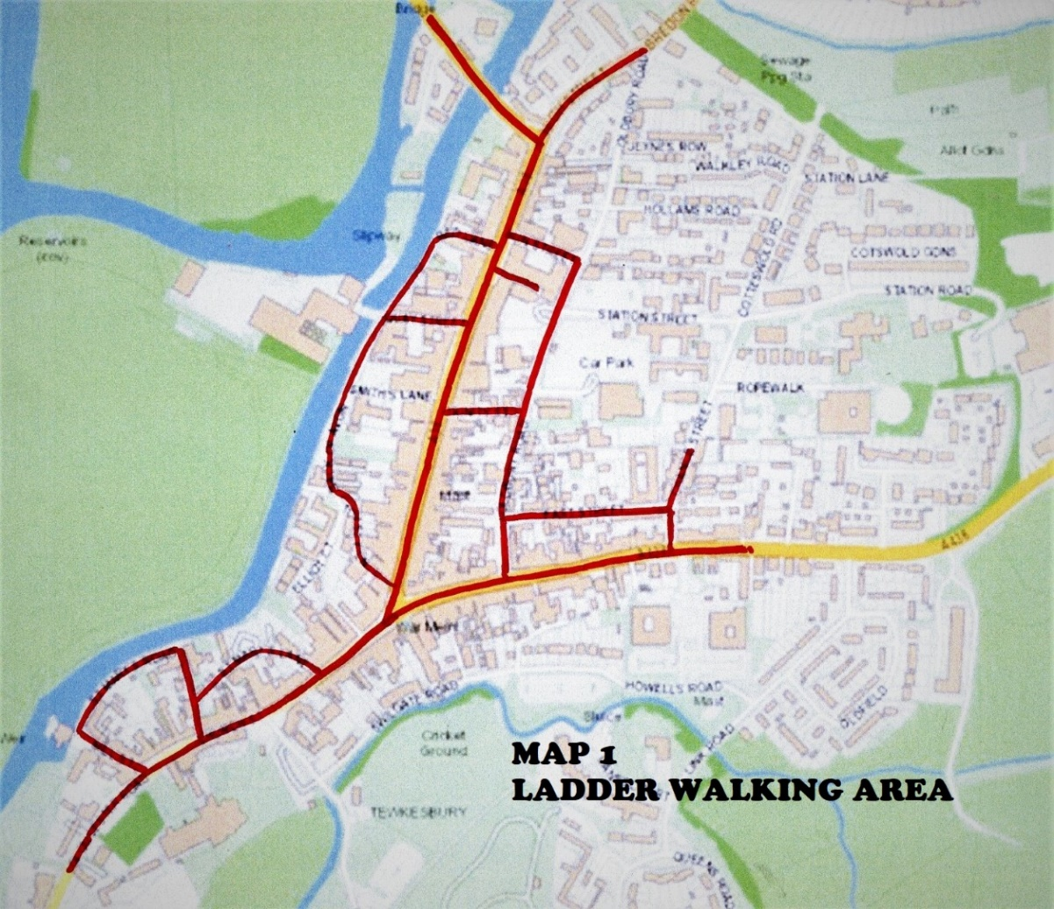

ZONE 2: MAIN ROUTES
a. For properties visible from the main driving routes into Town (Gloucester Road and Ashchurch Road) or visible from the Battle Trail walk or adjacent to the Festival site (Lincoln’s Green Lane and the Tewkesbury Park estate), as shown by the red lines on Map 2.
Banner provision will be as it always has been but as we are unable to erect them without bringing a ladder on a vehicle we will expect property owners to make their own arrangements to put them up and take them down. We will, of course, do our best to advise. We will deliver the banner in early June and collect at the end of September, unless other arrangements are made.
- For properties not on the main routes as shown on Map 2 which have a suitable bracket and are existing customers, the same arrangements as Zone 2a will apply.
- For other properties not on the main routes banners can be provided as explained below, under the Zone 3 heading.

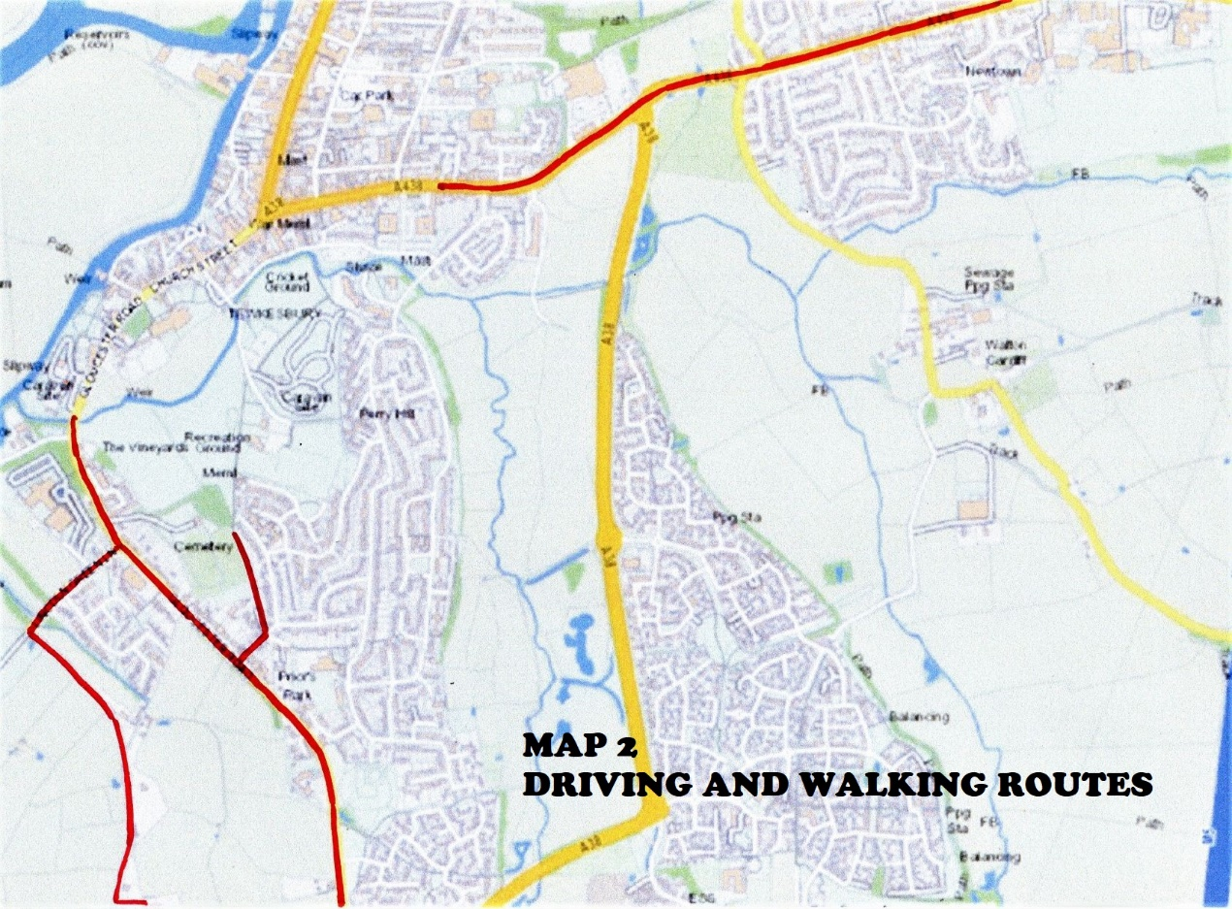

ZONE 3: EVERYWHERE ELSE
If you live outside these zones and want to display a banner, we don’t have the capacity to provide one under our standard terms. However, we can source a high-quality printed banner from an approved manufacturer, using our art-work, for you. It would be a sale, not a hire arrangement, and you would be responsible for looking after the banner.

BRACKETS
Brackets are entirely the property occupier’s responsibility. Subject to availability we can supply brackets and suggest someone to fix them to the wall. Please ensure that the banner and bracket are covered by your property insurance.

COSTS
Banner hire for the summer: £30
Printed banner to purchase: £40
Bracket to purchase: £TBA

